**USER STORIES:**

-> It is a simple description of feature/function from end user.

-> User stories are used to capture requirement in agile project and help the development team understand the needs and expectations of users.

-> User stories are key component of agile software development

High priority - user stories need to be in detailed

Low priority - user stories need to be short in detailed

**What is Good User Stories?**

1. Card : Written description of story used for planning and as a reminder.

2.Conversation : Conversation about the stories that serve to flesh out the details of the story

3.Confirmation : Acceptance criteria that should be fullfilled and tested to ensure user requirement have met.

**Who can create a user stories?**

1. Developer.

2. Team member.

3. product owner.->ownership will be with him

4. Some times ->scrum master.

Acceptence criteria come up with the team, product owner decide to priority or depriortise. So, acceptence criteria is with product owner.

**EPICS, AND INITIATIVES?**

1. User stories are also the building blocks of larger agile frameworks like epics and initiatives.

2. Epics are large work items broken down into a set of stories, and multiple epics comprise an initiative.

3. These larger structures ensure that the day-to-day work of the development team (on stores) contributes to the organizational goals built into epics and initiatives.

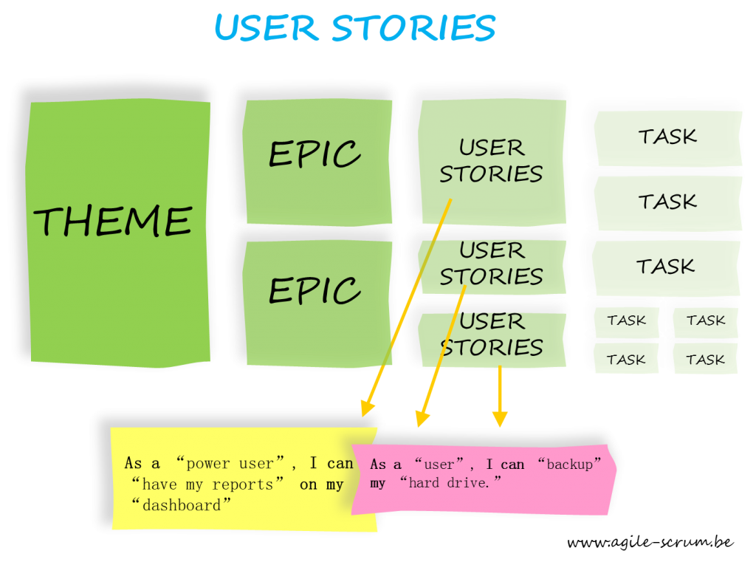

**There are 4 types of User Stories:**

1. Simple: These are individual or self-contained user stories that focus on a particular user or type of product.

2. Epic: Groups of related user stories come together to form epics. They may involve multiple users working together or independently or multiple needs for a single type of user to achieve some goal or benefit.

3. Thematic: These are major investments and strategies that group epics together. Thematic user stories highlight how a company will achieve wider goals.

4. Scaled Agile Framework (SAFe): These user stories add extra details such as a benefit hypothesis, cost of delay, or nonfunctional requirements.

**Why are user stories important?**

User stories help devs focus on the end user. Instead of thinking about their product in a vacuum, user stories capture functionality from an outside perspective. So instead of thinking about what a tool does, devs consider how it helps users.

User stories also play a key role in Agile development by:

-> Providing a sense of structure

-> Highlighting a user’s needs and priorities for devs

-> Pointing out the actual value found in a product

-> Exploring the "who," "what," and "why" in development to give devs essential context.

**How to create a User Stories: (steps)**

1. Identify user roles

2. Understand customer needs

As a <user role>, I want <something>, so that <benefit>.

3. Keep stories independant and valuable

4. Priortize user stories

5. Add acceptance criteria

6. Estimate efforts

7. Iterate and refine

8. Review and validate

9. Document and organize

10. Iterate and improve

**EXAMPLES OF USER STORIES:**

1. As a banking customer, I want to transfer funds between my accounts, so I can manage my money effectively.

**Requirements**: The system should allow customers to select two accounts, enter an amount, and execute a transfer. The system should update the account balances immediately.

2. As a website visitor, I want to be able to search for products by keyword so that I can quickly find what I'm looking for.

**Requirement**: The website shall include a search bar prominently displayed on every page. Upon entering a keyword and submitting the search query, the system shall return relevant products matching the keyword in their title, description, or tags.

3. As a customer, I want to be able to add items to my shopping cart and proceed to checkout.

**Requirement**: The website shall provide an "Add to Cart" button next to each product displayed. When clicked, the selected item shall be added to the user's shopping cart. The user shall be able to view and edit their cart contents before proceeding to checkout, where they can enter shipping and payment information.